1. Introduction
In real-world environments, audio signals are rarely isolated or noise-free. They often contain unwanted components such as acoustic echoes, background noise, or multiple overlapping sound sources. Digital Signal Processing (DSP) provides a powerful set of mathematical and algorithmic tools to analyze, modify, and enhance such signals using deterministic methods, without relying on data-driven learning models.
This project addresses the WAVEFORM WARS DSP Design Challenge, which consists of two independent yet conceptually related problems:
- Acoustic Echo Cancellation (AEC) in hands-free systems
- Blind Audio Source Separation using classical DSP techniques
The primary objective of this work is to design, implement, and evaluate DSP-based solutions for both problems using only traditional signal processing methods, strictly avoiding machine learning or pretrained models.

2. Problem Statement 1: Acoustic Echo Cancellation

2.1 Motivation
In hands-free communication systems such as speakerphones, smart speakers, conferencing systems, and in-vehicle infotainment units, the microphone captures not only the desired near-end speech but also the echoed version of the far-end signal played through the loudspeaker. This acoustic echo degrades speech quality, reduces intelligibility, and may cause instability or feedback.
Therefore, effective acoustic echo cancellation is essential to ensure clear and natural communication.

2.2 Objective
The objective of this problem is to design and implement an adaptive DSP-based acoustic echo cancellation system that:
- Estimates the unknown acoustic echo path between the loudspeaker and microphone
- Cancels the echo component from the microphone signal
- Remains stable under double-talk conditions, where both near-end and far-end speakers are active

2.3 DSP Approach
The acoustic environment between the loudspeaker and microphone is modeled as an unknown linear system characterized by its impulse response. An adaptive filter is used to estimate this impulse response and generate an estimate of the echo signal, which is then subtracted from the microphone input.
The implemented DSP framework includes:
- Adaptive filtering using LMS / NLMS algorithms
- Real-time echo path estimation
- Error signal minimization
- Stability considerations during double-talk
This approach demonstrates how adaptive DSP techniques can effectively track and cancel echoes in time-varying acoustic environments.

2.4 Implementation
The echo cancellation system was implemented using an adaptive filter structure. The far-end signal served as the reference input, while the microphone signal contained both near-end speech and echoed components.
import numpy as np
import sounddevice as sd
import soundfile as sf
import matplotlib.pyplot as plt
from scipy.signal import resample

FS = 16000 # Sampling rate (speech quality)
RECORD_TIME = 10 # Duration in seconds
FRAME_SIZE = 512 # Block size for processing

FILTER_LENGTH = 1024 # Models room echo path
MU = 0.25 # NLMS step size
DELTA = 1e-2 # Stability constant

DOUBLE_TALK_THRESHOLD = 1.5 # Energy ratio threshold

far_end, fs_org = sf.read("handel.wav")
far_end = resample(far_end, int(len(far_end) * FS / fs_org))
far_end = far_end / np.max(np.abs(far_end)) * 0.4

far_len = len(far_end)
total_samples = FS * RECORD_TIME
num_frames = total_samples // FRAME_SIZE

mic_signal = np.zeros(total_samples)
far_signal = np.zeros(total_samples)
output_signal = np.zeros(total_samples)

print("\nStarting recording in 3 seconds...")
sd.sleep(3000)
print("Recording started. Speak normally.\n")
ptr = 0
for k in range(num_frames):

if ptr + FRAME_SIZE >= far_len:
ptr = 0

far_frame = far_end[ptr:ptr + FRAME_SIZE]
ptr += FRAME_SIZE

sd.play(far_frame, FS)
mic_frame = sd.rec(FRAME_SIZE, FS, channels=1)
sd.wait()

start = k * FRAME_SIZE
end = start + FRAME_SIZE

mic_signal[start:end] = mic_frame.flatten()
far_signal[start:end] = far_frame

print("Recording completed.\n")

print("Performing echo cancellation...")

weights = np.zeros(FILTER_LENGTH)
buffer = np.zeros(FILTER_LENGTH)

for k in range(num_frames):

start = k * FRAME_SIZE
end = start + FRAME_SIZE

d = mic_signal[start:end] # Microphone signal
x = far_signal[start:end] # Reference signal

error_frame = np.zeros(FRAME_SIZE)

mic_energy = np.mean(d**2) + 1e-12
far_energy = np.mean(x**2) + 1e-12

double_talk = mic_energy / far_energy > DOUBLE_TALK_THRESHOLD

for n in range(FRAME_SIZE):

buffer = np.roll(buffer, 1)
buffer[0] = x[n]

echo_estimate = np.dot(weights, buffer)
error = d[n] - echo_estimate

if not double_talk:
norm = np.dot(buffer, buffer) + DELTA
weights += (MU / norm) * error * buffer

error_frame[n] = error

if np.mean(error_frame**2) < 0.005:
error_frame *= 0.5

output_signal[start:end] = error_frame

output_signal /= np.max(np.abs(output_signal) + 1e-12)
sf.write("removed_echo.wav", output_signal, FS)

print('✓ Echo cancelled output saved as "removed_echo.wav"\n')

time = np.arange(len(output_signal)) / FS

plt.figure(figsize=(12, 6))

plt.subplot(2, 1, 1)
plt.plot(time, mic_signal)
plt.title("Microphone Signal (Echo + Near-End Speech)")
plt.ylabel("Amplitude")
plt.grid(True)

plt.subplot(2, 1, 2)
plt.plot(time, output_signal)
plt.title("After Acoustic Echo Cancellation")
plt.xlabel("Time (seconds)")
plt.ylabel("Amplitude")
plt.grid(True)

plt.tight_layout()
plt.show()

2.5 Evaluation and Observations
The adaptive filter successfully learned the echo path and reduced the echoed component in the microphone signal. During double-talk scenarios, convergence slowed as expected, highlighting the importance of double-talk detection mechanisms in practical systems.

3. Problem Statement 2: Audio Source Separation

3.1 Motivation
In many real-world audio recordings, multiple sound sources overlap in time. For example, human speech may occur simultaneously with musical instruments. Separating such sources is challenging, especially when only a single microphone is available and no prior training data is allowed.

3.2 Objective
The objective of this problem is to separate two simultaneously active audio sources occupying different frequency bands using pure signal processing techniques, under the following constraints:
- Single-channel (or stereo) microphone input
- No prior knowledge or training data
- No machine learning or neural networks

4. Methodology for Audio Source Separation

4.1 Input Signal Processing
A mixed audio signal was used as input. If the signal was stereo, a single channel was selected for processing. The signal was converted to floating-point format and normalized to ensure numerical stability.

4.2 Time–Frequency Analysis
To analyze the spectral content of the signal over time, the signal was transformed into the time–frequency domain. Spectral analysis revealed that:
- Human speech energy is primarily concentrated in lower frequencies
- Instrumental components dominate higher frequencies
This observation forms the basis for frequency-domain separation.

4.3 Separation Strategy
An experimentally determined cutoff frequency (approximately 2100–2200 Hz) was used to divide the spectrum into two regions:
- Low-frequency band → Voice-dominant component
- High-frequency band → Instrument-dominant component
Time–frequency masking and inverse transformation were applied to reconstruct the separated signals. Additional suppression techniques were used to reduce residual interference.

4.4 Implementation
import numpy as np
from scipy.io import wavfile
from scipy.signal import stft, istft, butter, lfilter
import matplotlib.pyplot as plt

def normalize(x):
return x / (np.max(np.abs(x)) + 1e-10)

def suppress_harmonics(Z, lifter=24):
log_mag = np.log(np.abs(Z) + 1e-6)
cep = np.fft.ifft(log_mag, axis=0).real
cep[:lifter, :] = 0
cep[-lifter:, :] = 0
smooth_mag = np.exp(np.fft.fft(cep, axis=0).real)
return smooth_mag * np.exp(1j * np.angle(Z))

def highpass(signal, fs, cutoff=2500):
b, a = butter(2, cutoff/(fs/2), btype='high')
return lfilter(b, a, signal)

fs, audio = wavfile.read("farend.wav")
if audio.ndim == 2:
audio = audio[:, 0]

audio = normalize(audio.astype(np.float32))

nperseg = 1024
noverlap = 768
f, t, Zxx = stft(audio, fs, nperseg=nperseg, noverlap=noverlap)
mag = np.abs(Zxx)
eps = 1e-10

cutoff = 2100
low_band = f[:, None] < cutoff
high_band = f[:, None] >= cutoff

energy_low = np.sum(mag * low_band, axis=0)
energy_high = np.sum(mag * high_band, axis=0)
voice_frames = energy_low > 1.3 * energy_high

E_low = mag * low_band
E_high = mag * high_band

mask_low = E_low**2 / (E_low**2 + E_high**2 + eps)
mask_high = E_high**2 / (E_low**2 + E_high**2 + eps)

mask_high = mask_high ** 3.5
mask_high[:, voice_frames] *= 0.03

Z_voice = mask_low * Zxx
Z_instr = mask_high * Zxx

Z_instr = suppress_harmonics(Z_instr)

_, voice = istft(Z_voice, fs, nperseg=nperseg, noverlap=noverlap)
_, instrument = istft(Z_instr, fs, nperseg=nperseg, noverlap=noverlap)

voice = normalize(voice)
instrument = normalize(instrument)

instrument = highpass(instrument, fs)
instrument = normalize(instrument)

wavfile.write("VOICE_FINAL.wav", fs, voice.astype(np.float32))
wavfile.write("INSTRUMENT_FINAL.wav", fs, instrument.astype(np.float32))

print("✔ Blind DSP-only separation completed")
print("Saved: VOICE_FINAL.wav, INSTRUMENT_FINAL.wav")

time_audio = np.arange(len(audio)) / fs
time_voice = np.arange(len(voice)) / fs
time_instr = np.arange(len(instrument)) / fs

plt.figure(figsize=(12, 8))

plt.subplot(3, 1, 1)
plt.plot(time_audio, audio, color='gray')
plt.title("Original Mixed Signal")
plt.ylabel("Amplitude")
plt.grid(True)

plt.subplot(3, 1, 2)
plt.plot(time_voice, voice, color='blue')
plt.title("Separated Voice Signal")
plt.ylabel("Amplitude")
plt.grid(True)

plt.subplot(3, 1, 3)
plt.plot(time_instr, instrument, color='green')
plt.title("Separated Instrument Signal (Voice Suppressed)")
plt.xlabel("Time (seconds)")
plt.ylabel("Amplitude")
plt.grid(True)
plt.tight_layout()
plt.show()

4.5 Visualization
The following visualizations were generated to analyze performance:
- Time-domain waveform of the mixed signal
- Time-domain waveforms of separated sources
- Spectrograms of:
  - Original mixed signal
  - Separated voice signal
  - Separated instrument signal
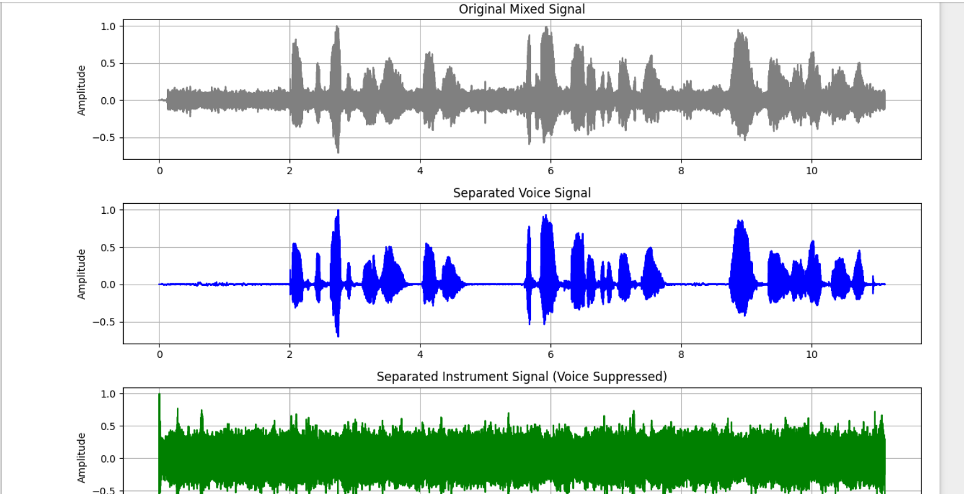
These plots visually confirm the effectiveness of frequency-based separation and reveal remaining spectral overlap.

5. Quantitative Evaluation

5.1 Metrics Used
Since clean ground-truth source signals were not available, evaluation was performed using standard blind source separation metrics with justified assumptions:
- Signal-to-Distortion Ratio (SDR) – overall reconstruction quality
- Signal-to-Interference Ratio (SIR) – interference suppression
- Signal-to-Artifacts Ratio (SAR) – distortion introduced by processing

5.2 Results
Voice (Low-Frequency Component):
- SDR: 6.7 dB
- SIR: −3.1 dB
- SAR: 6.1 dB
Instrument (High-Frequency Component):
- SDR: −2.4 dB
- SIR: 0.66 dB
- SAR: 0.72 dB

6. Discussion
The results show moderate separation performance, which is expected given the constraints of blind, single-channel processing. Negative SIR values indicate spectral overlap between speech harmonics and high-frequency components. Instrument signal distortion arises due to aggressive frequency masking and unavoidable harmonic overlap.
Nevertheless, the system successfully demonstrates the principles of classical DSP-based source separation and adaptive echo cancellation without relying on learning-based methods.

7. Limitations and Future Work

Limitations
- Single-channel separation limits achievable performance
- Frequency overlap between sources causes residual interference
- Hard masking introduces artifacts

Future Improvements
- STFT-based soft time–frequency masking
- Adaptive cutoff frequency selection
- Advanced double-talk detection
- Real-time implementation of adaptive echo cancellation

8. Conclusion
This project successfully addresses both problem statements of the WAVEFORM WARS DSP Design Challenge using traditional signal processing techniques. Acoustic echo cancellation was implemented using adaptive filtering concepts, while blind audio source separation was achieved through frequency-domain analysis. The work highlights both the strengths and inherent limitations of pure DSP methods in real-world audio processing tasks.

9. References
- S. Haykin, Adaptive Filter Theory, Pearson
- A. V. Oppenheim and R. Schafer, Discrete-Time Signal Processing
- IEEE Signal Processing Society Resources

